Empirical formula of Magnesium oxide

The empirical formula of a compound is the simplest value of the ratio of atoms of each element in the compound.

The equation is:

* Magnesium + oxygen → magnesium oxide
* 2Mg + O2 → 2MgO

Aims

To determine the empirical formula of Magnesium oxide (MgO)

Apparatus/Equipment

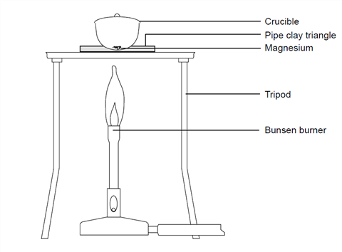

* Electronic balance
* Crucible with lid
* Bunsen burner
* Steel Wool
* Crucible tongs
* Pipe clay triangle
* Tripod
* Heat resistant mat

*Chemicals*

* Magnesium ribbon (~10-15cm long)

Risk Assessment

|  |  |
| --- | --- |
| What are the risks in doing this experiment? | How can you manage these risks to stay safe? |
| Burning magnesium is bright and cause damage to your eyes. | Wear appropriate safety gear, including eye protection (goggles). Don’t not look directly at burning magnesium. |
| Using a Bunsen burner will make objects very hot. | Do not touch the hot crucible or tripod with your hands. Always use crucible tongs. |

Procedure/Method

1. Cut a piece of magnesium about 10–15 cm long. If it is looking tarnished or black then clean it using the emery paper. Twist it into a loose coil.
2. Weigh the crucible with the lid (**MASS 1**) and then the magnesium inside the crucible with the lid (**MASS 2**).
3. Set up the Bunsen burner on the heat resistant mat with the tripod. Place the pipe clay triangle over the tripod, ensuring that it is secure. Place the crucible containing the magnesium in the pipe clay triangle and put the lid on.
4. Light the Bunsen burner and begin to heat the crucible. It is best to start with a gentle blue flame, but you will need to use the Bunsen burner with the air hole fully open to get the reaction to go.
5. Once the crucible is hot, gently lift the lid with the tongs a little to allow some oxygen to get in. You may see the magnesium begin to flare up. If the lid is off for too long then the magnesium oxide product will begin to escape. Don’t let this happen.
6. Keep heating and lifting the lid until you see no further reaction. At this point, remove the lid and heat for another couple of minutes. Replace the lid if it appears that you are losing some product.
7. Turn off the Bunsen burner and allow the apparatus to cool.
8. Re-weigh the crucible with lid containing the product (**MASS 3**).
9. Heat the crucible again for a couple of minutes and once again allow to cool. Repeat this step until the mass readings are consistent. This is known as heating to constant mass.

Results

|  |  |  |
| --- | --- | --- |
| Mass of crucible and lid [**MASS 1**] | = |  |
| Mass of crucible, lid and magnesium [**MASS 2**] | = |  |
| Mass of magnesium **[= MASS 1 - MASS 2]** | = |  |
| Mass of crucible, lid and magnesium oxide [**MASS 3**] | = |  |
| Mass of magnesium oxide **[= MASS 3 – MASS 1]** | = |  |
| Mass of oxygen combined with magnesium **[= MASS 3 – MASS 2]** | = |  |

Discussion

1. From your results table calculate
2. The mass of magnesium which reacted
3. The mass of oxygen combined with the magnesium
4. Calculate the numbers of moles of magnesium and oxygen and the ratio n(Mg):n(O).
5. What is the empirical formula off magnesium oxide?
6. Why are the crucible and lid heated at the beginning of the experiment before being weighted?
7. What are the possible sources of error in this experiment?

<https://edu.rsc.org/experiments/the-change-in-mass-when-magnesium-burns/718.article>